Vh7 Swivel Drive Gear Motor for Horizontal Single Axis Solar Tracker System
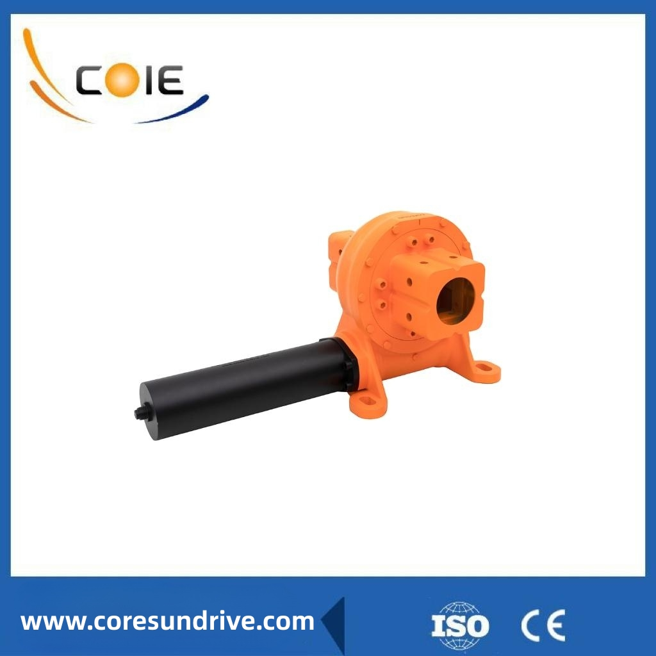

Many solar tracking devices have been developed. Single-axis control means only one axis automatically tracks the daily motion of the sun.

The seasonal changes in the sun's path cannot be tracked automatically, but manual adjustments can be made to maximize the sunlight over the course of the year.

If an adjustment is done each season, the angle from the horizontal is typically set to the latitude −15° in the summer (flatter orientation) when the sun is high, 0° in fall and spring, and +15° in winter (steeper orientation) when the sun is low.

These seasonal tilt angles, in which the array faces south for the northern hemisphere and north for the southern hemisphere. (Ignore the negative sign for southern latitudes.)

For a single-axis tracker, the rotating axis is normally the vertical axis which moves the collector east to west during the day.

With the rotation on the vertical axis, the collector maintains a constant clearance from the ground. The collector is titled from the ground plane by an amount approximately equal to the latitude, and the collector is turned to the east in the morning and slowly turns to face west in the evening.

After sunset, active trackers reset to the east to be ready for the following day, but as mentioned previously, passive trackers require sunlight to reset.

An array of single-axis trackers that are driving flat panels. The vertical axis is the only one that tracks.

Production Description:
Model | VH7 | Brand | Coresun Drive
Application | Solar Tracker | Type | Enclosed
Material | 42CrMo,50Mn | Output Torque(max.) | 10.5kN.m
Tilting Moment(max.) | 10kN.m | Holding Torque | 42kN.m
Static Axial Rating | 100kN | Static Radial Rating | 65 kN
Gear Ratio | 60:1 | Efficiency | 35%

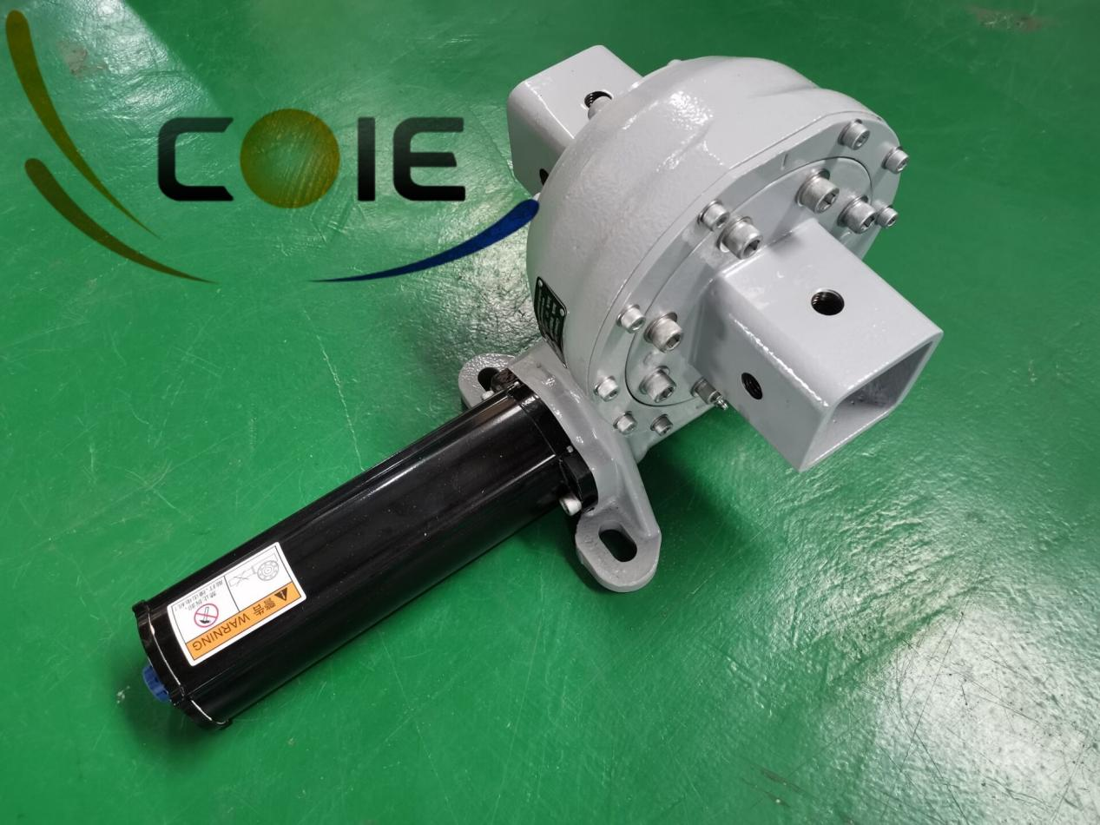

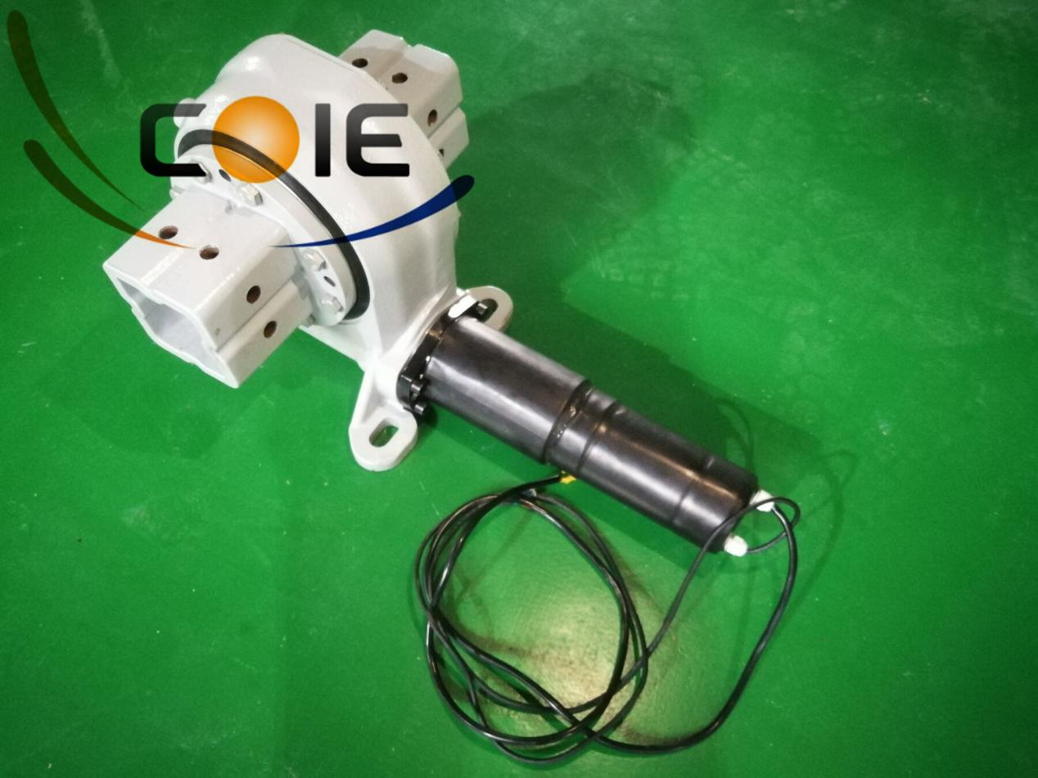

The factory has a first-class technology research and development team, production and processing equipment, comprehensive testing center, robot manufacturing line, automatic assembly line, etc. It can achieve an annual output of 200000 sets of rotary reducers, and its products are widely used in fields such as new energy, engineering machinery equipment, medical equipment, industrial automation, etc. The company is committed to reducing industry costs and improving industry efficiency as its development goal, innovating technology, and leading the industry.

1. Special design based on different applications and projects

2. Different types of motors could be matched, such as hydraulic motors, stepper motors, electrical motors etc.

3. Different colors are available based on RAL code; our standard color is RAL 9006.

4. Connection of a driving motor from the left or right side

5. During installation, it is not necessary to adjust the gearing clearance; this is already set by the producer before factory

6. Simple installation and low maintenance

7. Rational space utilization

8. The gear is self-locking; therefore a brake is not necessary

9. Easy and fluent method of starting and stopping

